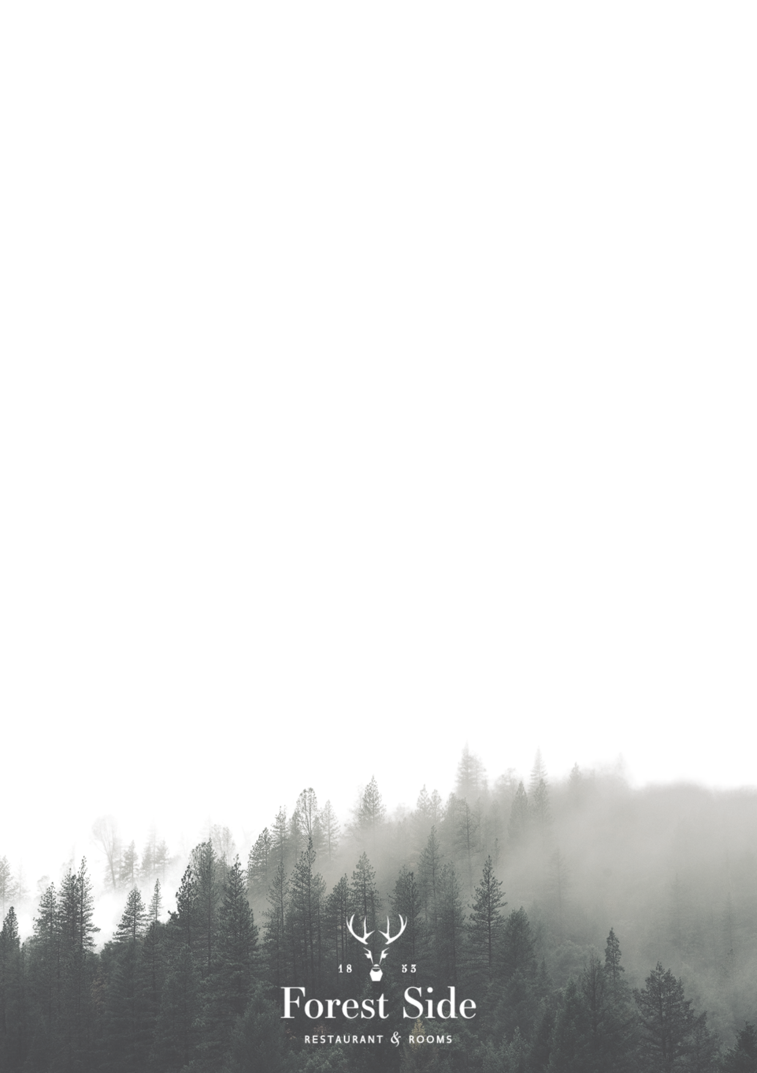
Rise & Shine
Juice- Freshly Squeezed Orange, Apple or Pink Grapefruit
Today’s Smoothie
Jing Tea or Our Grain House Blend Coffee
Buck Fizz £11
Delamotte Champagne £16
To Start
Fresh Fruit Salad
Cereal- Cornflakes, Special K, Bran Flakes, Luxury Muesli
Porridge- Whisky & Honey, Apple & Cinnamon or Strawberry & Vanilla
Our Granola Served with Vanilla Yoghurt and Strawberry & Vanilla Compote
Pink Grapefruit with Ginger & Garden Mint
Toasted Crumpets
To Follow
Eggs Benedict
Cumbrian Dry Cured Bacon, Brown Butter Hollandaise,
Poached Lakeland Free Range Eggs & Toasted Muffin
Eggs Royal
Cartmel Valley Smoked Salmon, Brown Butter Hollandaise,
Poached Lakeland Free Range Eggs & Toasted Muffin
Full Cumbrian Breakfast
With Your Choice Of Lakeland Free Range Eggs
Cartmel Valley Smoked Salmon
Scrambled Eggs & Toasted Crumpet
Wild Mushrooms
Poached Lakeland Free Range Eggs,
Hafod Cheddar & Rye Toast
Smashed Avocado
Toasted Seeds, Tomato Chutney,
Poached Lakeland Free Range Eggs & Rye Toast

Please Inform A Member of The Team Of Any
Dietary Requirements When Placing Your Order

